A Guide to Enhancing Confidentiality w/

Asymmetric Encryption by: Curtis Crawford

In this guide we’re going to review how to easily create & send encrypted messages, as well as how to decrypt messages that you receive! Let’s begin.

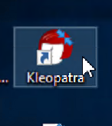Step 1: Locate & Open Kleopatra on your Windows1 Machine (or whatever machine you’re using to complete the process).

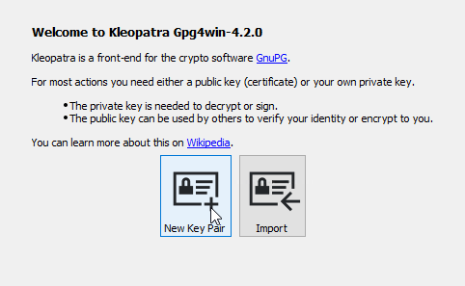Step 2: On the welcome screen, select “New Key Pair”.

Step 3: Enter a Name (email is optional) for your certificate.

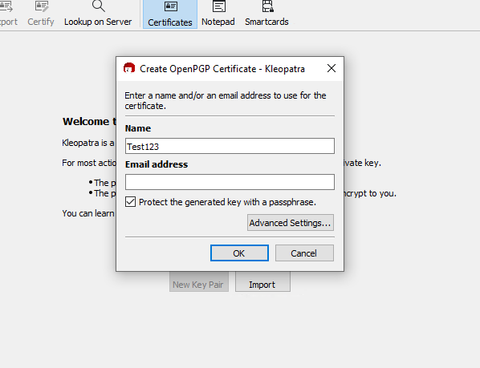Don’t forget to check the box beside “Protect the generated key with a passphrase”

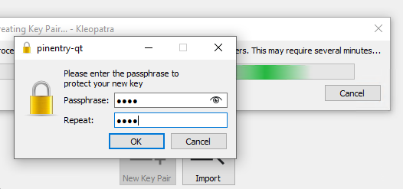Step 4: Enter a passphrase to protect your new key.

Step 5: Right-click on your new key and make a backup, this will be your “private” key.

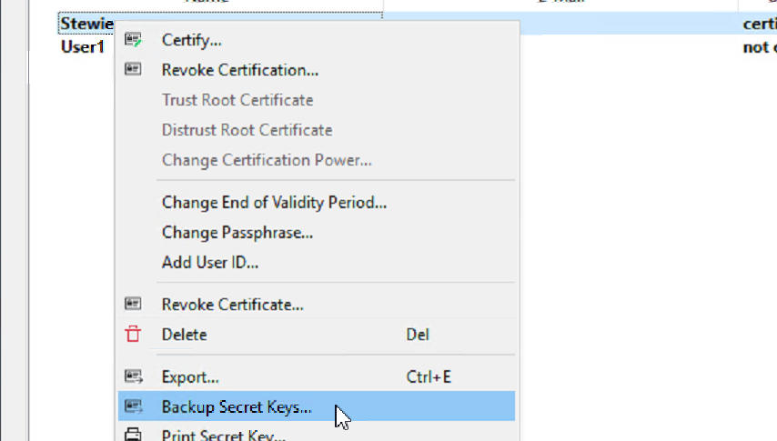

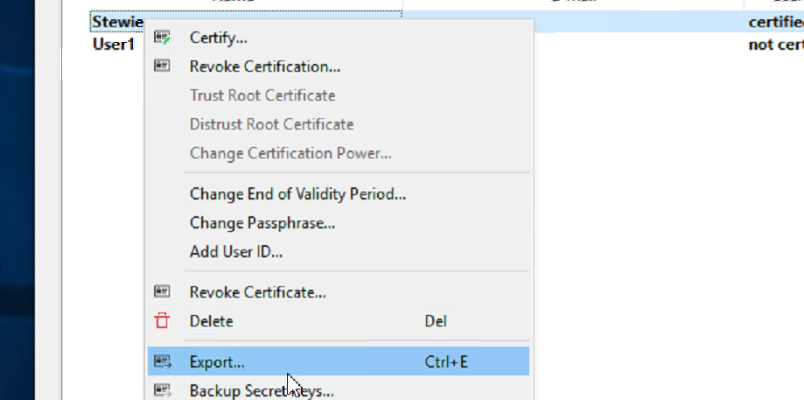Step 6: Right-click on your key and select Export to create a shareable public key.

Step 7: You should now have copies of your Public & Secret Keys that you can share with whomever you wish to communicate with. Go ahead and receive your partner’s keys and then simply drag and drop them into your Kleopatra.



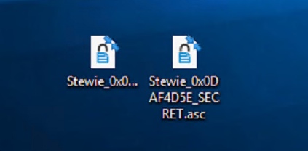

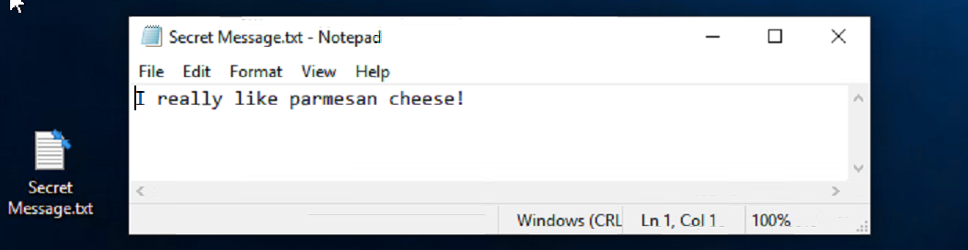Step 8: Create a new .txt document* and type out the message that you’d like to send.

* **You can also perform this step directly from the “Notepad” on Kleopatra!**

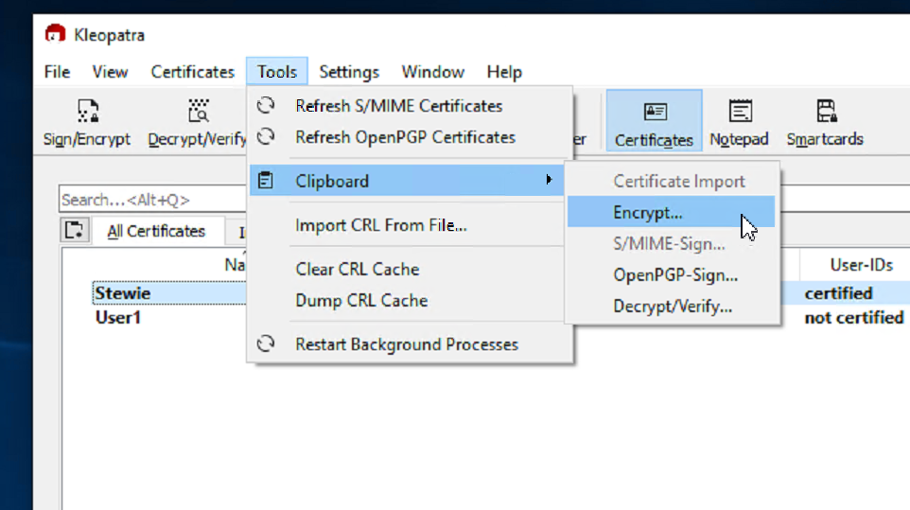Step 9: Head back to Kleopatra, then go to Tools > Clipboard > Encrypt.

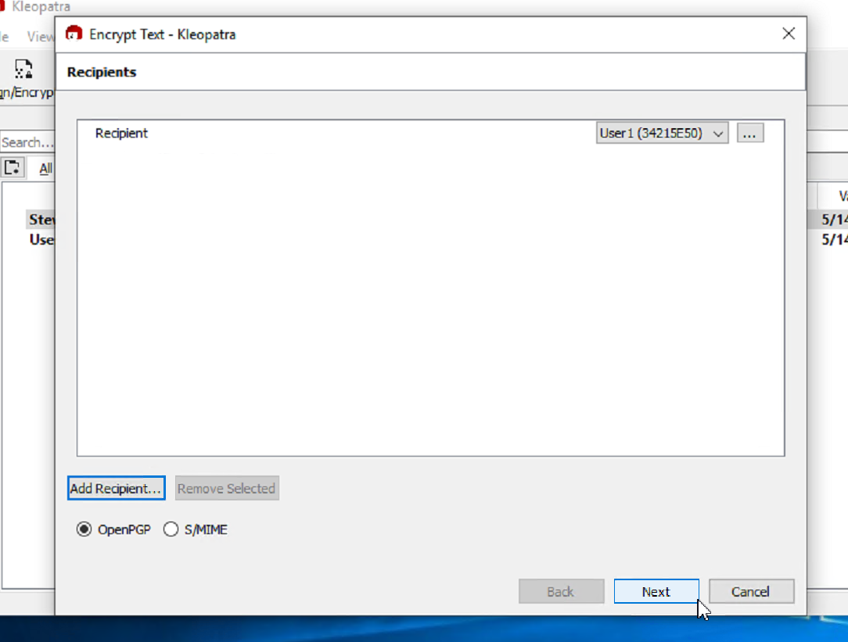Step 10: After receiving your partner’s keys and adding them to your Kleopatra, make sure to select them as a recipient to your message and select OpenPGP.

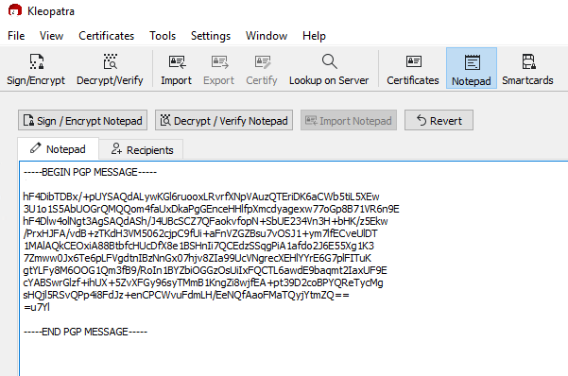Step 11: Your message will now be encrypted and copied to your clipboard. Simply open up your .txt document and paste to view it! For this step, I’ve personally decided to use the Notepad option on Kleopatra itself.

Step 12: Let’s say that the message above is from our partner and we wish to decrypt it, all you have to do is click the “Decrypt / Verify Notepad” button. *



\***Ensure that the header/footer are included in your message or the decryption will not work! It should look exactly like the image above with:**  
 -----BEGIN PGP MESSAGE----- at the start   
&  
 -----END PGP MESSAGE----- at the end  
If you receive the error *“Could not determine whether this is an S/MIME or an OpenPGP signature/cipthertext – maybe it is neither ciphertext nor a signature?”,* it is most likely because there is an issue with your header/footer

Step 13: Read the decrypted message!

Step 14: Have fun sending encrypted messages!!

